Practical 9 (part - 1)
NAME: TASNEEM SADIKOT
PRN: 23070521162
SEM: 5 SEC: B

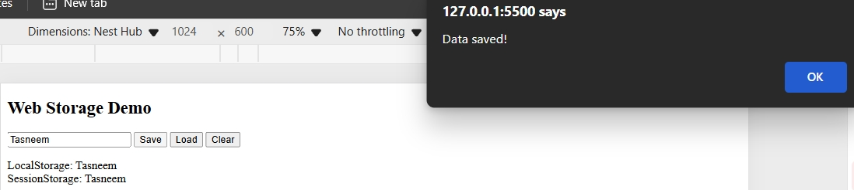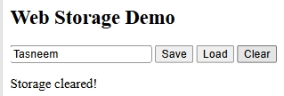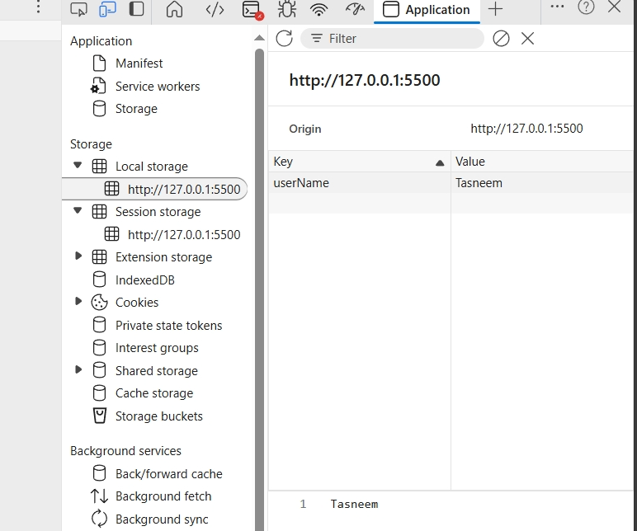
<!DOCTYPE html>
<html lang="en">
<head>
<meta charset="UTF-8">
<title>Web Storage Example</title>
</head>
<body>
<h2>Web Storage Demo</h2>

<input type="text" id="username" placeholder="Enter your name">
<button onclick="saveData()">Save</button>
<button onclick="loadData()">Load</button>
<button onclick="clearData()">Clear</button>

<p id="output"></p>

<script>
function saveData() {
let name = document.getElementById("username").value;
localStorage.setItem("userName", name);
sessionStorage.setItem("sessionName", name);
alert("Data saved!");
}

function loadData() {
let localName = localStorage.getItem("userName");
let sessionName = sessionStorage.getItem("sessionName");
document.getElementById("output").innerHTML =
`LocalStorage: ${localName} <br> SessionStorage: ${sessionName}`;
}

function clearData() {
localStorage.clear();
sessionStorage.clear();
document.getElementById("output").innerHTML = "Storage cleared!";
}
</script>
</body>
</html>

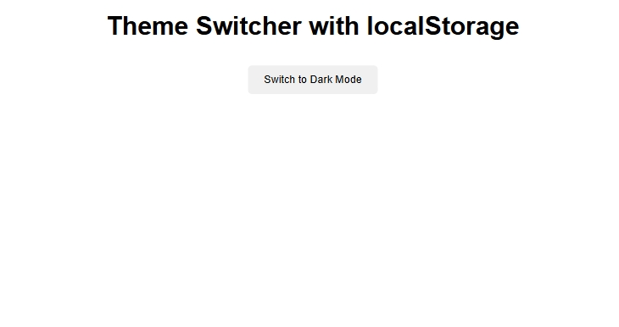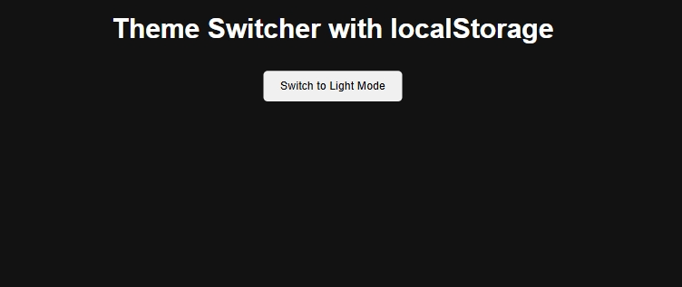
<!DOCTYPE html>
<html lang="en">
<head>
<meta charset="UTF-8">
<title>Theme Switcher</title>
<style>
body {
font-family: Arial;
text-align: center;
transition: background-color 0.5s, color 0.5s;
}
.dark {
background-color: #121212;
color: white;
}
.light {
background-color: #ffffff;
color: black;
}
button {
margin: 10px;
padding: 10px 20px;
border: none;
cursor: pointer;
border-radius: 5px;
}
</style>
</head>
<body>
<h1>Theme Switcher with localStorage</h1>
<button id="toggleTheme">Toggle Theme</button>

<script>
const body = document.body;
const btn = document.getElementById("toggleTheme");

// 1. Load theme from localStorage on page load
const savedTheme = localStorage.getItem("theme") || "light";
body.classList.add(savedTheme);

// 2. Update button text
btn.textContent = savedTheme === "dark" ? "Switch to Light Mode" : "Switch to Dark Mode";

// 3. Toggle theme and save to localStorage
btn.addEventListener("click", () => {
const newTheme = body.classList.contains("dark") ? "light" : "dark";
body.className = newTheme; // switch theme
localStorage.setItem("theme", newTheme);
btn.textContent = newTheme === "dark" ? "Switch to Light Mode" : "Switch to Dark Mode";
});
</script>
</body>
</html>

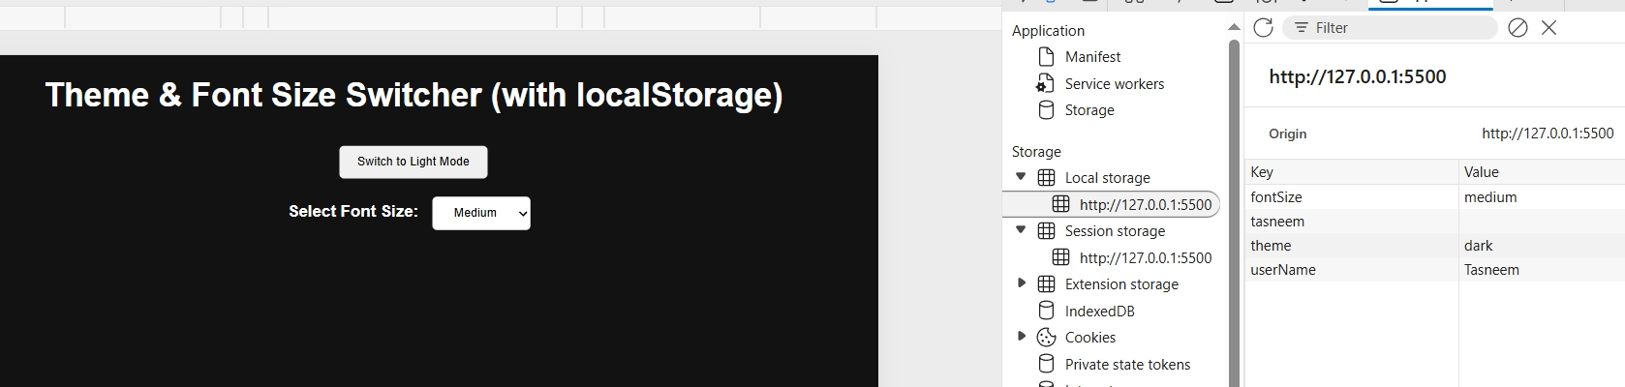
<!DOCTYPE html>
<html lang="en">
<head>
<meta charset="UTF-8">
<title>Theme & Font Preference</title>
<style>
body {
font-family: Arial;
text-align: center;
transition: background-color 0.5s, color 0.5s, font-size 0.3s;
}
.dark {
background-color: #121212;
color: white;
}
.light {
background-color: #ffffff;
color: black;
}
button, select {
margin: 10px;
padding: 10px 20px;
border: none;
cursor: pointer;
border-radius: 5px;
}
</style>
</head>
<body>
<h1>Theme & Font Size Switcher (with localStorage)</h1>

<button id="toggleTheme">Toggle Theme</button>

<br>
<label for="fontSizeSelect"><strong>Select Font Size:</strong></label>
<select id="fontSizeSelect">
<option value="small">Small</option>
<option value="medium">Medium</option>
<option value="large">Large</option>
</select>

<script>
const body = document.body;
const btn = document.getElementById("toggleTheme");
const fontSelect = document.getElementById("fontSizeSelect");

// Load saved preferences from localStorage
const savedTheme = localStorage.getItem("theme") || "light"; // default = light mode
const savedFontSize = localStorage.getItem("fontSize") || "medium"; // default = medium font

// Apply saved theme and font size on page load
body.classList.add(savedTheme);
applyFontSize(savedFontSize);

// Update button text and dropdown value based on current settings
btn.textContent = savedTheme === "dark" ? "Switch to Light Mode" : "Switch to Dark Mode";
fontSelect.value = savedFontSize;

// Toggle theme and save to localStorage
btn.addEventListener("click", () => {
const newTheme = body.classList.contains("dark") ? "light" : "dark"; // switch theme
body.className = newTheme; // apply new theme
localStorage.setItem("theme", newTheme); // save preference
btn.textContent = newTheme === "dark" ? "Switch to Light Mode" : "Switch to Dark Mode";
});

// Change font size and save to localStorage
fontSelect.addEventListener("change", () => {
const selectedSize = fontSelect.value;
applyFontSize(selectedSize); // apply new font size
localStorage.setItem("fontSize", selectedSize); // save preference
});

// Helper function to apply font size
function applyFontSize(size) {
if (size === "small") body.style.fontSize = "14px";
else if (size === "medium") body.style.fontSize = "18px";
else if (size === "large") body.style.fontSize = "22px";
}
</script>
</body>
</html>

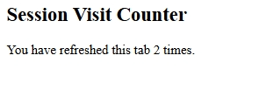
<!DOCTYPE html>
<html lang="en">
<head>
<meta charset="UTF-8">
<title>Session Counter</title>
</head>
<body>
<h2>Session Visit Counter</h2>
<p id="counter"></p>

<script>
if (sessionStorage.getItem("visits")) {
let count = Number(sessionStorage.getItem("visits")) + 1;
sessionStorage.setItem("visits", count);
} else {
sessionStorage.setItem("visits", 1);
}

document.getElementById("counter").textContent =
`You have refreshed this tab ${sessionStorage.getItem("visits")} times.`;
</script>
</body>
</html>

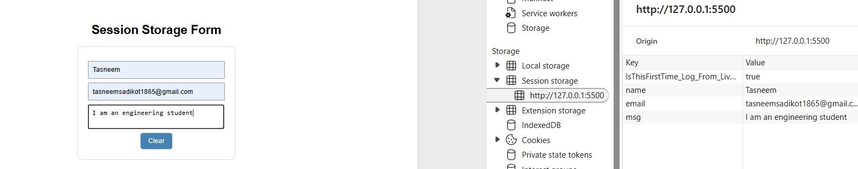
<!DOCTYPE html>
<html lang="en">
<head>
<meta charset="UTF-8">
<title>Session Form Storage</title>
<style>
body {font-family: Arial; text-align: center; margin-top: 50px;}
form {display: inline-block; padding: 20px; border: 1px solid #ccc; border-radius: 10px;}
input, textarea {width: 250px; margin: 8px 0; padding: 8px; display: block;}
button {padding: 8px 15px; border: none; background: steelblue; color: #fff; border-radius: 5px;}
</style>
</head>
<body>
<h2>Session Storage Form</h2>

<form id="f">
<input id="name" placeholder="Name">
<input id="email" type="email" placeholder="Email">
<textarea id="msg" placeholder="Message"></textarea>
<button type="reset">Clear</button>
</form>

<script>
// Restore previous data
["name", "email", "msg"].forEach(id => {
document.getElementById(id).value = sessionStorage.getItem(id) || "";
});

// Save on input
document.querySelectorAll("#f input, #f textarea").forEach(el => {
el.addEventListener("input", () => sessionStorage.setItem(el.id, el.value));
});

// Clear on reset
f.addEventListener("reset", () => sessionStorage.clear());
</script>
</body>
</html>

